Hexagon Housing Association

2015/16 Value for Money Self - Assessment

1. **Introduction**

Why Value for Money is important

For Hexagon, Value for Money (VFM) is about being effective in how we plan, manage and operate our business, it is important because

* Residents pay their rent and service charges in the expectation that we will make the best use of them to fulfil Hexagon’s objectives;
* Our main source of income (social housing rents) is constrained by a long term formula that links it to inflation +1%. Further constraints have been introduced by the Government, which means that most of our rents will reduce by 1% a year for four years from July 2016. We have to ensure that other costs rise by no more than rental income over the long term to secure Hexagon’s long term future; and
* Our regulators place great emphasis on VFM

How the Board monitors VFM

Our Board obtains assurance on VFM through a range of means including:

* A triennial VFM Strategy which it approves (current Strategy was approved in May 2014);
* Approving the annual Self-Assessment
* Reviewing delivery of the Strategy once a year (see Appendix C);
* A range of quarterly performance data which covers quality issues;
* Quarterly management accounts and treasury management updates;
* An annual report against the long term financial plan.

_____________________________________________________________

1. **Overall assessment**

Value for money is about outputs, outcomes and resident satisfaction as well as costs. Hexagon performs well in overall value for money, with particular strengths being as follows:

* The Board is prepared to make difficult decisions to withdraw from business streams that no longer meet Hexagon’s social and financial objectives, past examples being short-life housing and provision of support under supporting people contracts (other than for very specific needs);
* Other than responsive repairs, our services are provided at lower cost than average for London housing associations (see paragraph 3.2)
* Once data is adjusted for London weighting, figures from our Regulator show that our costs per social housing home managed are lower than those for 75% of English housing associations.
* We have an 8- year track record of keeping unit cost increases to less than inflation, in all areas other than major repairs and void repair costs (Appendix B)
* Our interest costs are lower than those of 75% of English housing associations (paragraph 3.6)
* We estimate that we save our general needs and co-op residents around £25m a year compared to market rents, which represents an 11.7% social return on the grants that the taxpayer has invested in these properties (paragraph 4.5)
* We have identified the most costly 15% of properties to repair and assess for disposal any of these that become empty using clear criteria, including an assessment of social value (paragraph 4.7)
* We have a VFM Strategy that contains challenging and measurable targets (Appendix C)

However, there are some specific areas where we want to do better, as follows:

* Resident satisfaction with our responsive repairs service is lower than for our London peers, and we take longer to complete repairs. This has been adversely affected in 2014/15 by the failure of our main responsive repairs contractor. We involved residents in choosing new contractors during 15/16, and are now seeing improvements in both satisfaction rates and repair completion times for 16/17 to date.
* We have used the opportunity of the new responsive repairs contracts put in place for 16/17 to reinstate IT interfaces with each contractor, with a view to improving our control of repair costs.
* Despite the difficulties of making our Victorian and Edwardian street properties energy-efficient, we are investing significant amounts of money to improve the average SAP rating of our homes.
* We still taking too long to relet empty properties, although a true comparison with our peers is difficult because we have not been enforcing the 4 week notice period for tenancies.

1. **Absolute and comparative costs of delivering specific services**

**What our services cost in 15/16**

3.1 The table in Appendix A shows the 15/16 cost of delivering services. Expenditure on building new homes accounted for 47% of expenditure during the year. The pie below chart shows the same data, but excluding development costs.

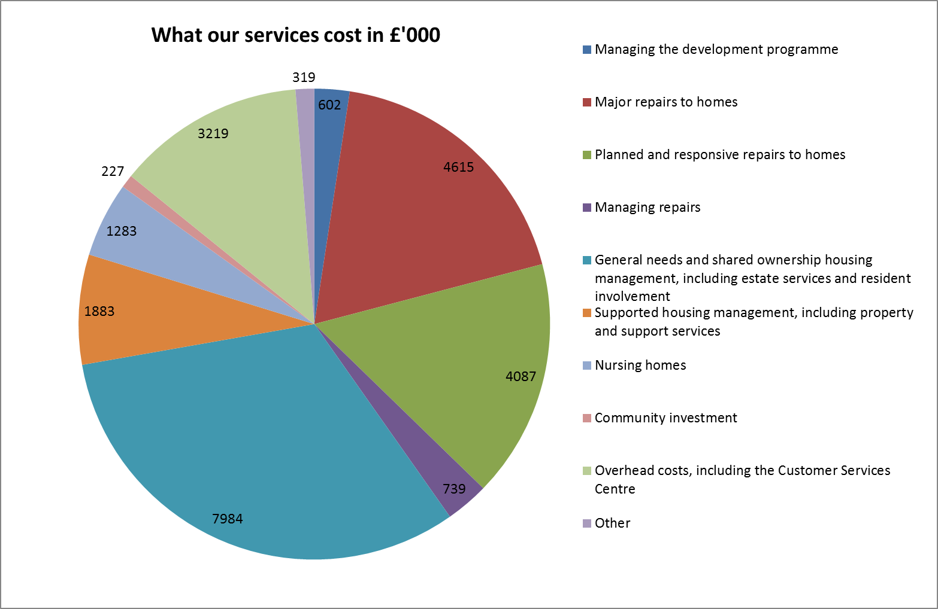

**How our services compared on cost and quality with other London housing associations**

3.2 Value for money is about outputs and outcomes as well as costs. The most recent summary data from HouseMark for 2014/15 (see chart below) shows that Hexagon achieves low costs in all service areas except repairs where costs went up during 20114/15 as a result of the need to use temporary contractors after our main contractor, ceased to trade. We achieved high performance as well as low costs for rent collection and estate services.

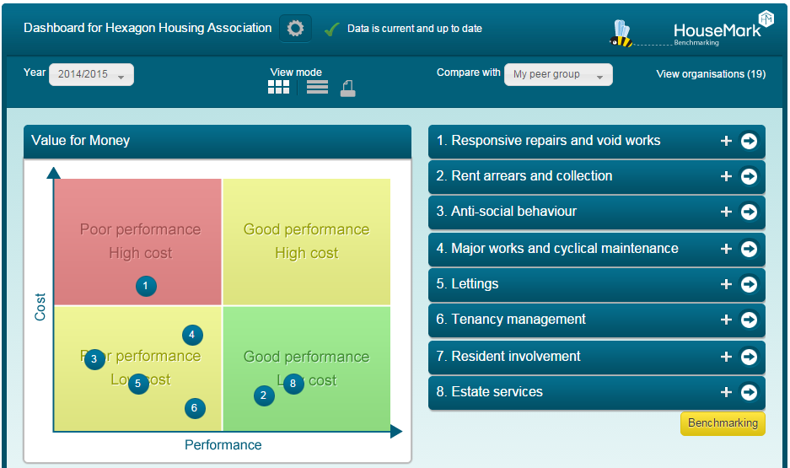

**What our services cost compared to other London housing associations**

3.3 The table below shows the comparative costs of Hexagon’s services, using the data from HouseMark. The services are as defined by HouseMark, so will allocate costs differently to Hexagon’s allocation. The data is from Hexagon’s 2014/15 results, compared to other London housing associations (30 organisations).



3.4 This indicates that Hexagon saved around £799k in 2014/15 by providing most services more cheaply than 75% of other London housing associations, but might be able to save a further £1,026k if the maintenance, shared ownership and premises costs were as economic as the best performers in these areas. However, our results for 2014/15 included a one-off maintenance provision of £573k which was written back in 15/16, so it would be more accurate to say that we could have saved £453k by being as economic as the best performers.

3.5 Because of the variety of services provided, HouseMark does not report on the costs per unit of supported housing and of developing new homes, but does provide a small suite of indicators on each. In developing new homes, we have more development staff than average for each 100 new homes built. However, this reflects our strategy of building on smaller infill sites, rather than relying on large schemes and S106 schemes. In 14/15 we also did less well than our peers on resident satisfaction with new homes, which is why our VFM strategy aims to increase this from 82.5% in 2013/14 to 92% by March 2017. The target was more than met in 2015/16, with 100% of residents being satisfied, albeit on a small number of surveys.

3.6 Hexagon borrows from banks and other financial institutions to fund the building of new homes and the improvement of existing homes. At March 2016, total borrowings were £152m, mainly on loans which need to be paid back gradually over the next 30 years. Interest charges on these loans form around 17% of Hexagon’s costs, so it is important that we manage these rates carefully. The Board aims to strike a balance between taking advantage of the best interest rates on offer without exposing the Association to large increases in costs when the official bank rate starts to rise. Benchmarking data from HouseMark showed that Hexagon's borrowing costs were in the best 25% of housing associations in both London and nationally in 2014/15.

**How our non-cost performance compares to other London Housing Associations**

3.8 Quality measures on which Hexagon performs better than average are as follows:



3.9 Areas where Hexagon performs worse than the median (mid-point) for the HouseMark 2014/15 data[1] are as follows:



3.10 The following actions are being taken to address weaknesses in quality of service:

* Average completion time – responsive repairs contracts for 16/17 onwards include penalties for contractors if target times are missed
* Satisfaction with repairs - responsive repairs contracts for 16/17 onwards include penalties for contractors if satisfaction targets are missed. We also plan to collect satisfaction data via hand held devices as soon as possible
* Satisfaction with the Anti Social Behaviour service – we plan to make changes to the way we provide the service, with more emphasis on regular updates to residents.
* Average re-let time - responsive repairs contracts for 16/17 onwards include penalties for contractors if void target times are missed. An improved system for recording and analysing other causes of delay is in place.

**Looking more widely – costs compared to those of other English housing associations**

3.11 In July 2016, the Board considered Hexagon’s headline social housing costs per property which had been circulated by the HCA and was derived from the 2015 global accounts data and broken down into several cost lines. This was compared to the equivalent figures for the sector as a whole.

This data is repeated below, adjusted firstly to take into account the London weighting that the HCA gave as contextual information, but did not use in the data, and secondly to adjust this weighting to reflect that around 15% of associations are London based. Generally, Hexagon uses the HouseMark for benchmarking as it is more detailed and is undertaken on a much more like-for-like basis. The nearest HouseMark data using our London HA benchmark is presented below the HCA data.

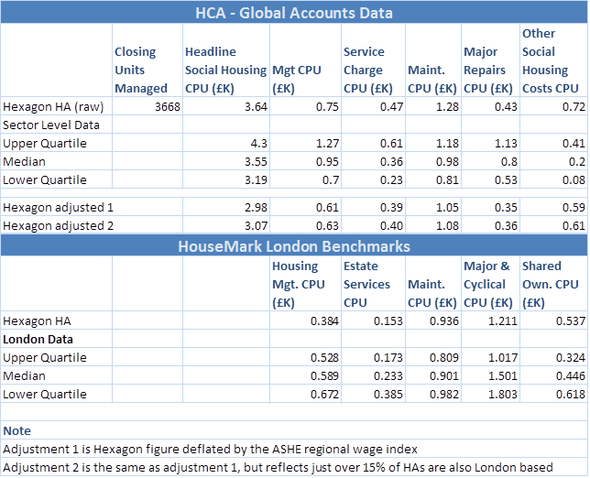

3.12Once adjusted to take the London weighting into account,the HCA data shows Hexagon’s cost per social housing unit in management to be better than 75% of English social landlords. However, within this our maintenance, service costs and “other” costs are higher than the median. This borne out by the second table which shows that our maintenance cost per unit is higher than the median for London, using HouseMark data. As explained elsewhere in this document, our maintenance costs for 14/15 were increased by the need to use temporary contractors for routine repairs. Our service costs look higher than the median because we have a relatively large proportion of supported housing (6.7% compared to the median of 1%), for which we provide more services. “Other” costs are higher by £0.22k a unit because they include costs for the 489 co-op and agency managed units which are not included in the units managed figure, and by £0.11 a unit because of the costs of support contracts which are recovered from the local authority commissioners. The remaining difference to the median may because we allocate to this line in our financial statements some costs such as resident newsletters and council tax on voids that other landlords may include with their housing management costs. We will review this for the 16/17 financial statements.

1. Our return on assets

4.1 Hexagon’s mission is to meet housing, care and support needs in South London and assist with economic and social regeneration. Our predominant area of operation is South East London. Our objectives for the three years to March 2017 are set out in our Corporate Plan.

Financial return on assets

4.2 Hexagon has received Social Housing Grant to enable us to charge below- market rents. For Hexagon to be a sustainable business, it is important that the return net of grant will pay the interest bill on our borrowings. The table below looks at the cost of Hexagon’s property assets, net of grant and depreciation and the surplus as reported in the 15/16 accounts to derive a financial return on each type of property, before interest. This compares to a projected long term interest rate of 4.2% for the loan portfolio at September 2015. The cost net of grant represents Hexagon’s investment in our properties, which is funded by our loans and reserves. The grant is the total of all capital grants provided over the years to allow Hexagon to let the properties at a subsidised rent, thus representing investment by taxpayers.

|  |  |  |  |  |  |
| --- | --- | --- | --- | --- | --- |
| Type of property asset | Cost net of grant £’000 | Grant  £’000 | 15/16 Surplus before interest  £’000 | **Financial return**  **% for 15/16** | Financial return  % for 14/15 |
| General needs | 171,949 | 195,287 | 8,691 | **5.1%** | 5.3% |
| Shared ownership | 19,006 | 11,321 | 1,031 | **5.4%** | 6.0% |
| Directly managed supported housing | 4,804 | 10,990 | 108 | **2.2%** | 1.1% |
| Co-op managed general needs | 8,110 | 17,482 | 621 | **7.7%** | 8.3% |
| Agency managed supported housing | 1,021 | 4,920 | 15 | **1.5%** | 5.0% |
| All main asset classes | 204,891 | 240,000 | 10,466 | **5.1%** | 5.4% |

4.3 The % financial return appears to have dropped from 5.4% to 5.1% since 14/15. However, this is because of the net extra depreciation included in the 15/16 surplus as a result of a change in accounting policies. Once this is adjusted for, the return on assets has actually risen by 0.2% between 14/15 and 15/16. The % financial return is greater on the older stock, such those managed by co-ops, as this was funded by high levels of grant. Supported housing shows lower rates of return because of the greater intensity of housing management and the higher risk of voids, but there is also a higher social return.

4.4 But how do we compare to non-social landlords? We have undertaken a calculation which, solely for the purpose of demonstrating value for money, compares our rents to those in the commercial sector. If we were to charge market rents for our general needs and co-op properties, then we estimate that we would make a financial return on 8.7% on the gross cost of our properties (i.e. assuming no grant). This compares well with the yields of 2.8%-5.4% on buy to let in South East London, but we do have the advantage of having refurbished or developed the properties over a number of years.

Social return on assets

4.5 Using the same calculation as for 4.4 above, we estimate that we would be able to charge £25m more a year for our general needs and co-op homes if we were a purely commercial organisation. This is a conservative estimate, as it excludes homes that we own but do not manage and is based on the Local Housing Allowance (LHA) rather than average rents; the LHA is the maximum amount of Housing Benefit that can be paid for a home of a particular size. So this one measure of the social return we provide as a result of the Government’s past investment of £213m of Social Housing Grant – a return of 11.7% pa.

4.6 The social return provided by our sub-market rents does not take account of the other social benefits accruing from our properties being in better maintained - the [2015 English House Condition Survey](https://www.gov.uk/government/uploads/system/uploads/attachment_data/file/501070/2014-15_Section_2_Housing_Stock_tables_and_figures_FINAL.xlsx) found that 28.6% of private rented homes failed the Decent Homes standard, compared with 12.8% for housing associations. Hexagon had no homes failing the Standard at the end of 2015/16. There is also the benefit of more energy-efficient homes – the [English House Condition Survey found in 2015](https://www.gov.uk/government/uploads/system/uploads/attachment_data/file/501070/2014-15_Section_2_Housing_Stock_tables_and_figures_FINAL.xlsx) that the private rented sector had an average SAP rating of 58.4, compared with a housing association average of 66.2 and a Hexagon average of 70.2.

4.6 The table below provides some other measures of the social return on our assets:

|  |  |  |
| --- | --- | --- |
| Type of property asset | Grant  £m | Social return |
| General needs | 195.3 | 2809 households in properties at or under target rents  355 households in properties at a discount of at least 20% to market rent  143 households on local authority waiting lists housed in 15/16  24 existing tenant households moved to more appropriate accommodation |
| Shared ownership | 11.3 | 220 households in homes that they have part-purchased.  13 households in homes at intermediate rent that they are saving for a deposit to buy.  9 households have been able to buy the remaining share of their home in 15/16. |
| Directly managed supported housing | 11.0 | 197 households in properties at target rents  13 households in properties at a discount of at least 20% to market rent  35 people housed from inappropriate accommodation (such as hostels, hospitals and very short-stay accommodation) during 15/16  5 existing tenant households moved to more appropriate accommodation |
| Co-op managed general needs | 17.5 | 294 households in properties at or under target rents being managed by tenant co-operatives. |
| Agency managed supported housing | 4.9 | 110 households in properties at target rents or funded by commissioning authorities  Of these 42 are in a scheme for single homeless people with additional support needs, 26 in a registered care home for people with alcohol, mental health and homelessness issues and 9 in a refuge for women who are in danger of domestic violence. |

**Disposal of properties that are uneconomic to repair**

4.7 At the centre of Hexagon’s approach to ensuring that we make an appropriate return on our assets is a review which has identified the homes that are the most expensive maintain both in terms of responsive costs and longer-term component replacement. This has highlighted about 15% of our homes and when empty these units receive an options appraisal to determine whether to either retain or sell and reinvest the receipts in new homes. As the review is now over two years old, we plan to implement some software which will enable the data to be kept up to date as stock improvement work is completed.

The options appraisal effectively asks a number of questions:

* How much the home is worth now?
* How much will the work (including energy efficiency improvements) cost?
* How much the property will be worth after the work?
* The ‘letability’ of the home after the work;
* Would replacement, as part of our Development programme be a better option? This includes looking at the Net Present Value of both options.

4.8 In the three and a half years to March 2016, 76 homes have been reviewed as part of this process – with 32 having been approved for sale with the remaining 44 (58%) being brought up to current standards then re-let. We have refined the process further as a result of a review we undertook during 2015/16, which led to the decision to implement new specialist software during 16/17.

1. **Value for money gains that have been made**

**Value for money gains that have been made in the medium term**

5.1 Since 2006/7, Hexagon has made significant cost savings in most areas. Appendix B presents a series of graphs which compares rent inflation at RPI +0.5%/ CPI +1% (the red line in each graph) to Hexagon’s cost per unit (the other line in each graph). With the exception of stock investment and works to void units (although there have been improvements over the last few years on this), Hexagon’s costs have risen more slowly than rent inflation, and in some areas have dropped in real terms. The baseline for stock investment was low in 2006/7, so it is appropriate that we are spending more in this area. The 2014/17 VFM strategy includes targets for addressing the cost of void works.

5.2 The graphs indicate a recent rising trend in costs per unit for responsive repairs costs, the management of responsive repairs and customer services. We had to allocate more staff to customer services in 14/15 to deal with resident queries arising from the failure of our main responsive repairs contractor half way through the year. Interim repairs arrangements put in place have led to far fewer queries, but costs per repair are still rising. Responsive and void repairs were re-tendered during 2015/16, and the new contracts were in place for 16/17.

**Value for money gains that have been made as a result of the 14/17 VFM strategy**

5.3 At the Board meeting in May 2014, the Board agreed a 3-year value for money strategy for the Association. The strategy focussed on six main areas (see section 6 below). Measurable targets covering both quality (Q) and costs/efficiency (C) were included in the strategy, which also includes actions to achieve the targets and to embed value for money throughout the organisation.

5.4 45 targets were set, 24 of which relate to costs and 21 to quality. Most of these have intermediate, annual, targets. For those with targets for 2015/16, 14 were met for 2016/17 with 17 not being met. Most of the remainder relate to 2015/16 HouseMark data which, at the time of writing, is going through the HouseMark validation process. Appendix C sets out the detail.

5.5 A summary of the value for money actions undertaken during 2015/16 as part of the VFM Strategy is set out in Appendix D, together with some further initiatives completed during the year. The most significant are:

* We have been able to double the Employment and Skills resource available to support residents into employment for the same cost to Hexagon due to 50% European Social Fund funding being secured - this is worth £183k over 3 years.
* We were able to achieve £35k worth of savings on our roof programme through a cost comparison exercise;
* We negotiated with contractors installing kitchens and bathrooms to hold prices to their 2013/14 levels – saving a total of £20k which we were able to invest in carrying out more works;
* We have recruited several administrators during the year through our Academy - this saves both in terms of recruitment costs but give the resident transferable skills in the wider job market – in one team alone we saved around £6.2k by doing this;

**6.0 Value for money gains to be made**

6.1 The 2014/17 VFM Strategy focuses on areas where benchmarking indicates that we could do better on either cost or quality, and where is significant expenditure. Broadly, these areas are as follows:

* Development and New Business;
* Treasury Management;
* Major and Cyclical Repairs;
* Responsive, gas safety checks & void repairs
* Supported Housing - Void management and making the best use of our properties
* Estate Services.

6.2 The Strategy, which is also available on our website, includes a set of 45 targets. A full list of the targets, which range from the cost of building new homes to resident satisfaction with our repair service, is set out in Appendix B.

6.3 The Strategy also sets out the actions we will take to meet the targets over the three years to March 17. Appendix E summarises the value for money initiatives to be undertaken during the year to March 17. In addition, Hexagon staff will be developing and reporting on initiatives across the organisation as a routine part of our culture of continuous improvement.

**Costs of providing each service in the year to March 16 Appendix A**



**How Hexagon’s costs per unit managed have moved since 2006/7 Appendix B**

** **

** **

** **

** **

** **

** **

[**Appendix C**](http://www.hexagon.org.uk/wp-content/uploads/2014/10/Appendix-C-Strategy-Update-2016.xlsx)

**Outcome of value for money initiatives planned for 2015/16 Appendix D**

| What | Why | Cost | Financial benefit | Social benefit | Outcome |
| --- | --- | --- | --- | --- | --- |
| Every development scheme in the 15/18 programme to have achieved start on site by September 2016 | To ensure timely completion. | An temporary increase in staffing to allow for more sites to be assessed and progressed, costing £36k | N/A | To provide the agreed programme of affordable housing as soon as possible. | This was effectively a target for 2016/17 and is not yet due. |
| Use the HALA procurement club framework for solicitor appointments | To obtain cost savings on the Association’s legal bills | Annual HALA fee of £7.6k | Savings in legal costs. | None | Savings of £40.4k achieved in 15/16. |
| Undertake a post implementation review of the new defects system | To ensure that the planned benefits of the system have been achieved. |  |  |  | This was completed and some changes made to the way in which defects are dealt with in Customer Services. |
| Join the SDS Catalyst benchmarking club | To obtain more detailed benchmarking information on our development performance. | Opportunity cost of staff time. | To identify and correct where Hexagon is overspending compared to our peers | Depends on outcome of benchmarking. | The ‘club’ was joined, although its size and the number of ‘London peer’ associations actively involved mean that the comparative data to date has been limited. More members of our L8 peer group are expected to join during 2016/17. |
| Set up at least one new derivative agreement | To reduce the risk of future cash calls if further interest rate swaps are needed | Estimated £10k in legal fees | None – this is to manage risk, rather than to save money | None | Not done – followed independent treasury advice to undertake embedded loan fixes instead |
| Arrange further funding facility | To fund the 15/18 development programme. | Arrangement, legal and security charging fees of £179k for a £22m loan. | Interest rate on the facility to be less than the 3.7% assumed in the Association’s budget | To enable provision of a further 200 units of affordable housing. | Loans of £34m arranged at a blended interest rate of 2.31% |
| Review our approach to identifying properties which should be sold | There may be factors, other than repair costs and poor social value, that make a property unfit for purpose. | Consultancy fees to help with this exercise. | Resources released to invest in properties which are better fit for purpose. |  | This was completed in 2015/16 with significant changes being actioned during 2016/17. |
| Improve SAP (energy efficiency) rating of existing homes through a combination of internal funding and external grant | To help address fuel poverty | A £220k budget for energy efficiency improvements in 15/16, in addition to the improvements planned from replacing worn-out boilers, windows and roofs | None to Hexagon | To reduce fuel poverty by ensuring that, by March 2017 no Hexagon resident lives in a property with a SAP rating lower than 65 | This is a really challenging target and we were a little way behind the interim target that we set for ourselves for 2015/16. |
| Gas contract to be retendered through a procurement club | To obtain services at best value | Annual procurement club fee of £8k, part of which supports other tender activity. | Estimated saving of £10k in procurement costs | Resident working group has an opportunity to shape the way that services are delivered. | This was undertaken through the South East Consortium (SEC) procurement club during 2015/16. |
| A review of voids to look at  • Where performance can be improved;  • The costs and benefits for better software to help track voids. | Improve performance on void turnaround time | None – review to be undertaken by business improvement team | Reduction in rent and service charges lost during void periods | Letting empty properties more quickly to households in need | Revised recording & reporting systems were produced during the year which has enabled a better understanding of trends in delays. |
| Improved reporting on void activity to effectively monitor void  expenditure and manage performance | As above | As above | As above | As above | See previous |
| Review the use of PDAs for obtaining survey data about cyclical repairs if the response rate dies not improve during 15/16. | To identify the most effective survey method. |  |  |  | This happened during 2015/16 – with tablets purchased for the use of Planned Surveyors. |
| Retender the Cleaning and Grounds Maintenance contracts | To obtain services at best value, with some enhancements of service delivery | £8k plus opportunity costs of staff time. | For residents, the aim is to provide a better service for the same cost.  For Hexagon, there may be a small improvement in un-recoverable services charges. | Resident working group has an opportunity to shape the way that services are delivered. | This was done during 2015/16, with new contracts starting in May 2016. |
| Assess the impact of the new contracts officer on resident satisfaction with estate services. | To check whether the new post is improving services to residents. |  |  |  | This was reviewed and felt to be making a positive impact so the post was made permanent. |

[**Appendix E**](http://www.hexagon.org.uk/wp-content/uploads/2014/10/Appendix-E-VFM-tasks-for-2016-17.xlsx)

1. We generally use all London housing associations and data for the most recent year as our benchmark within HouseMark, however, this option is not possible on the ‘public’ dashboard which is for housing associations of up to 7500 homes and also includes data for 20113/14 where the organisation has not submitted data in 2012/13.