Hexagon Housing Association

Board of Management
24 November 2015

Agenda Item 8

Quarter 2 Management Accounts - Quarter Ending September 15

Report by the Finance Manager

Summary
This report looks at the financial results for the 6 months to 30th September 2015, and the current forecast for the full year.

1 | Summary: 6 months to 30th September 2015  The total surplus for the 6 months to 30th September 2015 is £4,360k compared to a budget of £4,459k, an adverse variance of £99k.  Operating surplus is £4,706k compared to a budget of £4,776k, an adverse variance of £70k.  Areas where we have positive variances include office overheads, other operational costs, staff cost and Stock Improvement Programme (SIP) revenue spend.  The main areas of adverse variance are responsive repairs, cyclical maintenance, service charge income and interest payable.  The forecast to the end of the year shows that overall surplus will be less than the budget by £339k.
 | 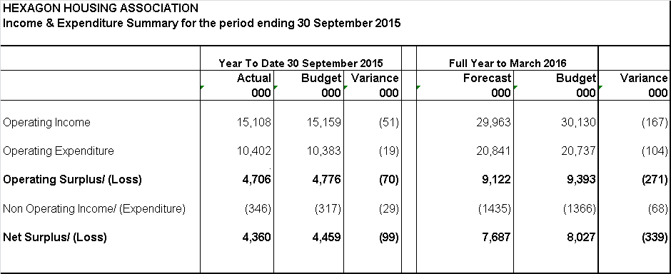
2 | Review of results 6 months to 30th September 2015  Favourable  Adverse  A full table of the results is included below:  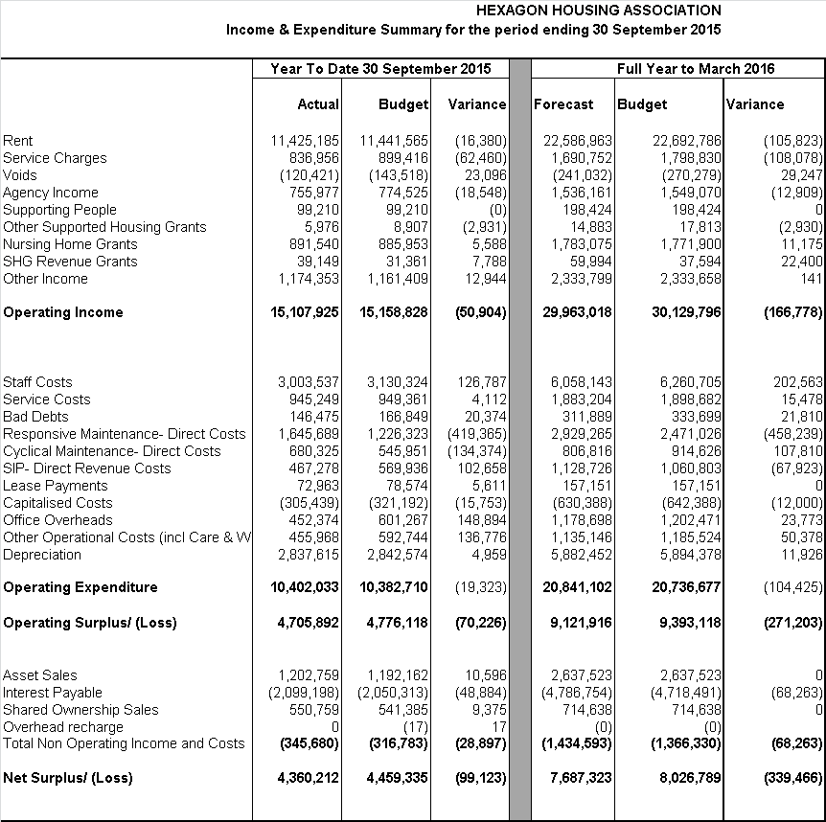
  Office Overheads is £149k below budget. This is due to underspends in consultancy £17k, computer maintenance and repairs £25k, financing costs £16k, telephone £16k, department & central training £11k and advertising & public relations £14k.
  Other Operational Costs is £137k below budget. This includes £77k in contingency cost, £28k in insurance – leases, £45k in property insurance and £12k in tenants’ welfare. There have been overspends in abortive costs £21k, home loss payment £16k and compensation cost £17k.
  Staff Cost is £126k below budget. This is mainly due to delays in recruitment for vacant and new posts. There have been underspends in business improvement, housing management and nursing homes.
  SIP revenue cost is under spent by £103k. This is mainly due to delay in energy efficiency programme and delay in receiving invoices for roof guttering work. SIP revenue is expected to be overspent by the end of the year a result of work in Cromwell Flats.
  Responsive maintenance is £419k above budget. This is mainly due to overspends in day to day maintenance GN £448k. Gas servicing is showing £34k underspend, while void in general needs is overspent by £7k. Please see appendix 1 for further details.
  Cyclical maintenance direct cost is £134k over spent. This is mainly in general needs which is currently £150k overspent. This is due to the majority of general needs programme completing earlier in the budget phasing. The overall year end position is actually forecast to be £107k underspent as a result of actual costs being less than the cost assumed at budget setting.
  Interest Payable is £49k above budget. We have capitalised £61k less than budgeted because of slower spending on schemes in development. This is being offset by savings generated from less interest on the new AHF loan, with £17m drawdown to date compared to £22m in the budget.
3 | Forecast Full Year position  The forecast full year surplus for 2015/16 is £7,687k compared to the budgeted surplus of £8,027k. Key changes from the budget are set out in the table below.  Reforecast Table
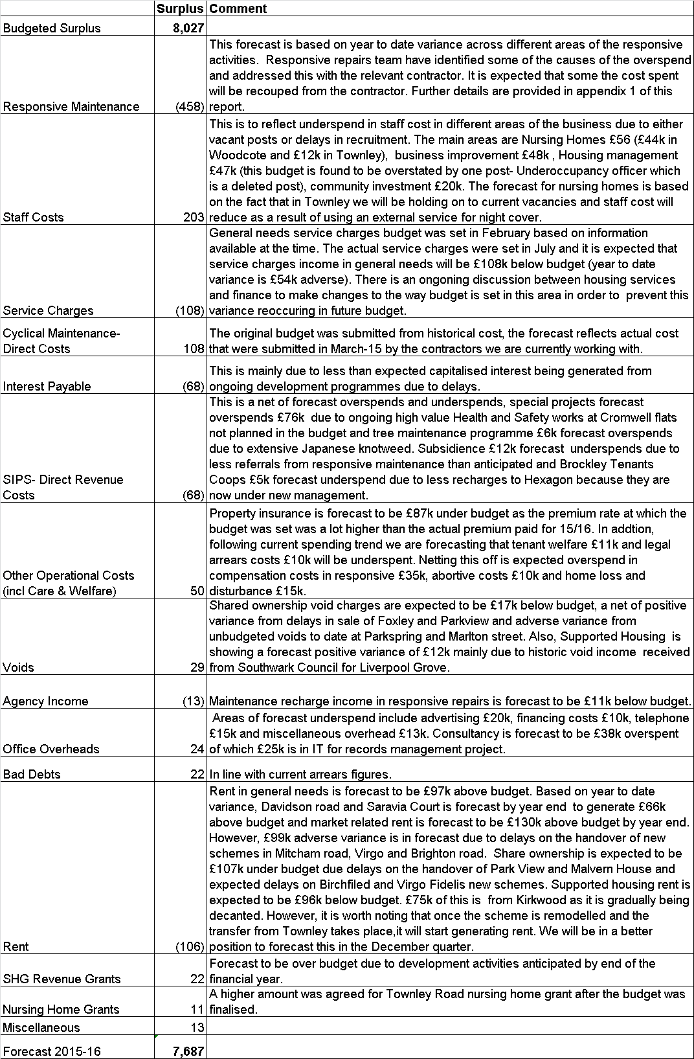
4 | 4 Responsive Maintenance, SIP and Cyclical  Responsive maintenance  Overall the budget is showing an overspend of £419k.  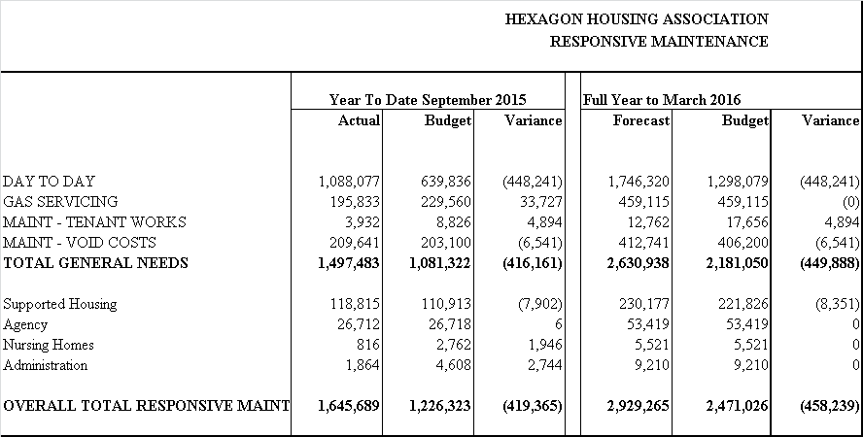  Please see Appendix 1 for detailed report on variances.  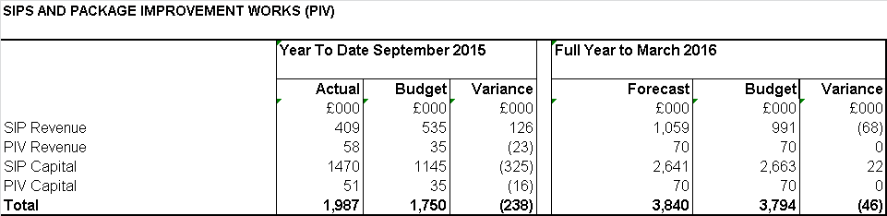  Main area of underspend in SIP revenue is £110k in energy efficiency because programmes are being delayed due to detailed analysis of the data for the energy programme by consultants – work will start in October. The is also a £55k underspend in roof guttering work due to awaiting contractors invoice – works are ongoing to programme on site and £17k underspend in Subsidence.  There are however overspends of £62k in special projects because of high value health and safety works to Cromwell Flats. There is also, a £23k overspend in package improvement works (PIV) due to doing a lot more PIV works and the tree maintenance programme is £23k overspent due to Japanese knotweed treatment at Mountacre and 5 other sites.  We are forecasting that SIP revenue will be overall £68k above budget. This is a net of £76k increase to special projects budget for Cromwell Flats and a £12k underspend in subsidence excess.  Main areas of overspends in SIP capital are boilers £146k mainly due to phasing, windows £49k due to being ahead of programme. Package improvement £39k is due to doing a lot more PIVs. Special projects are also showing £99k in capital due to Cromwell Flats as explained above.  SIP capital is forecast to be £22k under budget overall. This mainly due to combination of £15k increase to fire risk assessment budget due to more sign works required at new build sites and £32k increase to special projected netted by a projected underspend in windows programme of £76k due to delay to works on conservation properties where SIP team are awaiting approval.  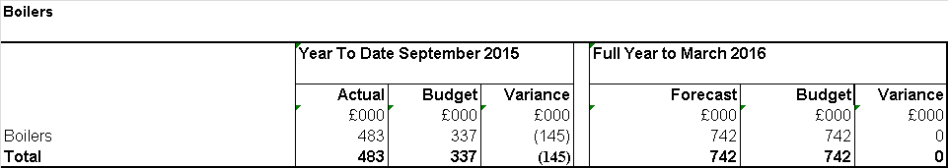  The current overspend is as a result of the programme being ahead.  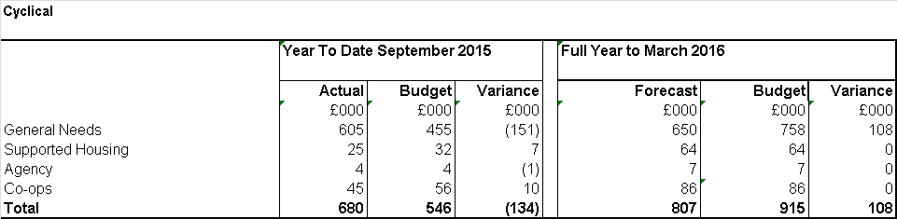
5 | 5 General Needs  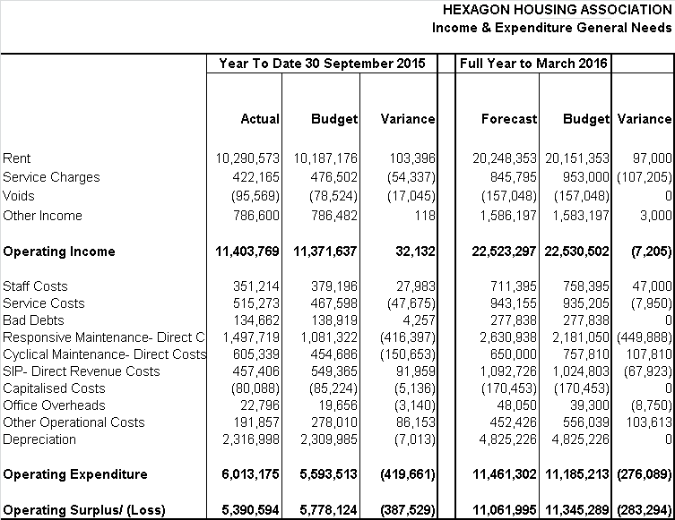  Responsive maintenance is £416k over budget. This is mainly due to overspends in day to day maintenance of £443k. However, there is a £34k underspend in gas servicing and over spend in void costs £7k. Appendix 1 gives more detail on the overspend.  Cyclical Maintenance is £151k over budget due to the cyclical programme completing ahead except estate improvement works which should start towards the end of October or the beginning of November (expected spend of £50k). Overall the cyclical budget is expected to be underspent by £108k due to actual costs being lower than historic cost that the budget was based on.  Other operational costs is £86k under spent mainly as a result of insurance leases £20k and property insurance £39k and £11k in tenants welfare. Home loss disturbance is showing £12k overspend due to compensation paid to 2 residents who had to be moved out of their homes due to serious disrepair and did not have the opportunity to return and therefore were entitled to statutory Home Loss Payment.  Service charges income is £54k below budget. This is as a result of actual service charge income for 2015/16 (set in July) being lower than budget. This is reflected in the service charge income forecast. There is an ongoing discussion between Housing Services and Finance to make changes to the way budget is set in this area in order to prevent this variance reoccurring in future.  Rental income is £103k above budget. This is due to market related rent being more than budget by £85k, Springbank and Davidson are also showing £33k above budget. However, new handover rent is under budget by £14k due to delays in Mitcham and Virgo Fidelis.  Voids is £17k above budget and is due to the relatively high losses incurred when voids are being considered for disposal. The number ‘in the system’ is reducing now so the rate of void loss should slow down.  SIPS Direct Revenue costs in general needs is £92k under budget, please see commentary in maintenance section of this report.
6 | 6 Shared Ownership  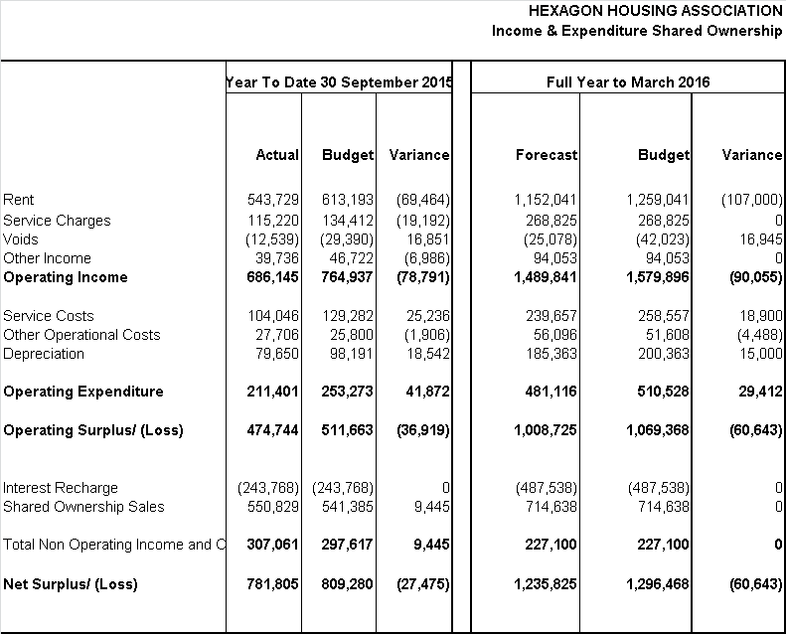  Rent is £69k under budget due to £16k lower rent from Foxley Road and £30k lower rent from Parkview both as a result of first tranche sale slower than planned in the budget. Also, £14k due to staircasings and £9k from delays of Birchfield and Virgo Fidelis  Void loss is £16k under budget this is a net of £29k underspend from Foxley and Parkview delays and £12k unbudgeted void loss from Parkspring court and Marlton Street. This is as a result of 1 repossessed unit at Marlton street in the process of being sold and rent to buy units at Parkspring court that are currently vacant also to being sold.  Service costs are £25k below budget due to underspends in communal repairs £13k, fire and other alarms £11k and service charge to freeholder £7k.
7 | 7 Supported Housing Lettings  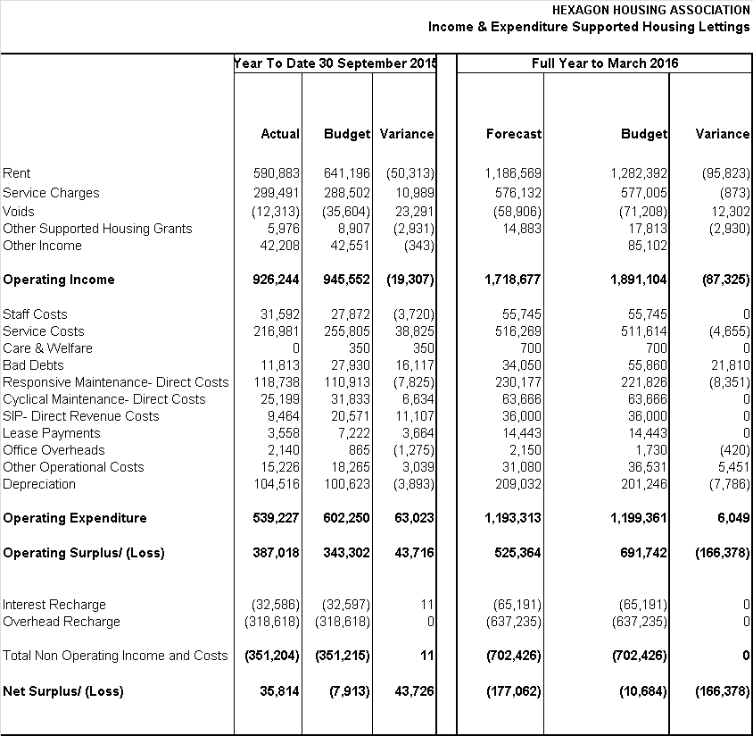  Rent is £50k under budget mainly due to £36k adverse variance in Kirkwood. This is as a result of scheme being remodelled. 11 out of 13 flats are now void. Rents are not being charged on the unlettable voids.  Service Costs are £39k under budget. This is due to underspend in multiple areas including central heating £8k, additional housing and managements costs £8k, furniture expense £7k and central heating fuel costs £5k.  SIP direct cost is £11k under the budget.  Bad debt is £16k under budget mainly as a result of £15k positive variance in Queens’s Road due to write back of the cumulative bad debt provision.  Responsive maintenance is showing an overspend of £8k which is a net of overspend of £9k in day to day and £2k in void costs and underspend in gas servicing £3k.
8 | 8 Supporting People  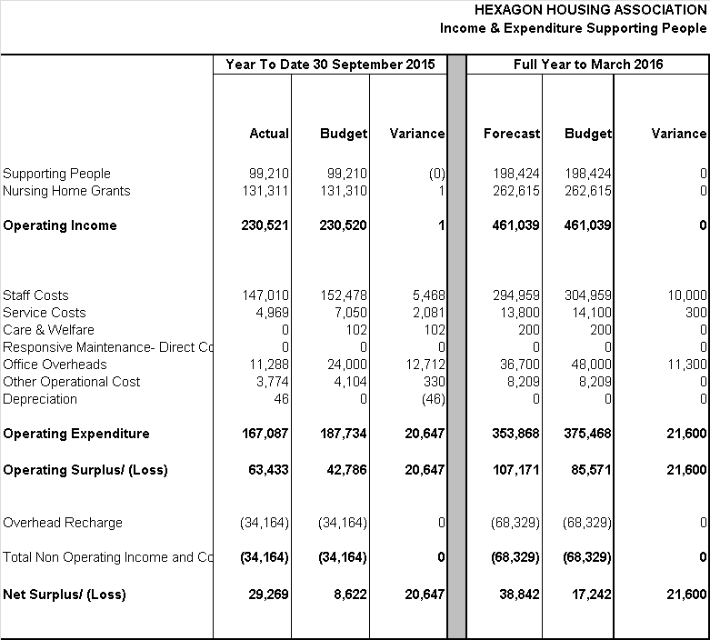  Income is in line with budget. Office overheads are £13k under budget mainly as a result of miscellaneous overheads £11k. Staff cost is £5k underspent due to one vacant post.
9 | 9 Nursing Homes  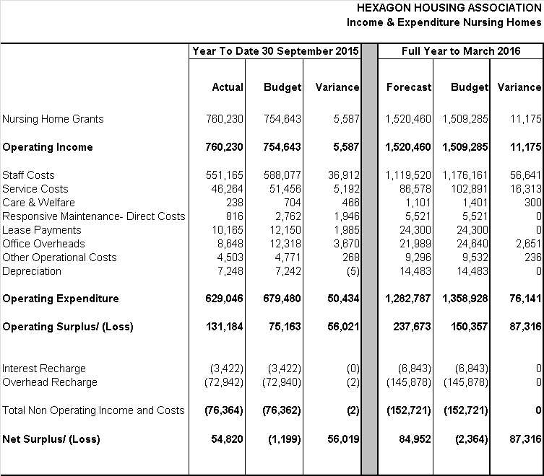  Staff cost is below budget by £37k. Both homes have vacancies which we are holding. We are restructuring both services in November and we will begin using an external organisation to provide the night cover. Not all of the vacant hours are being covered so both services under budget.  Nursing home grants is above budget by £5k.
10 | 10 Agency Management  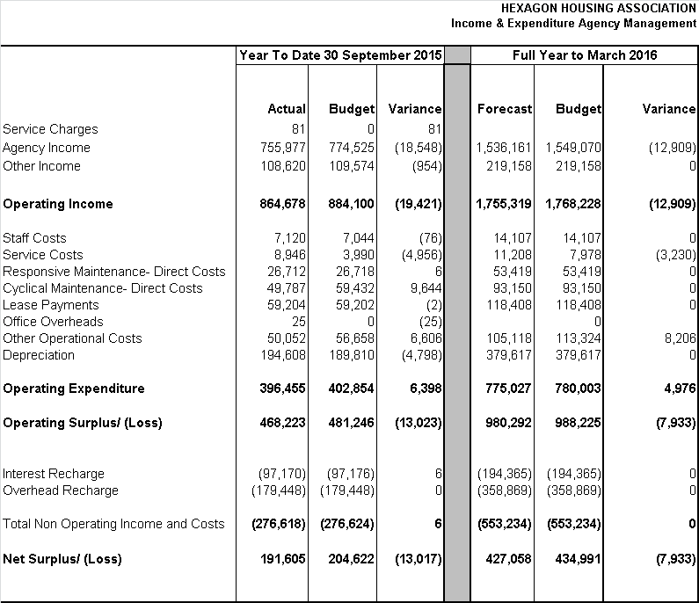  Agency income is £19k below budget. £12k of this is due to lower than budgeted maintenance recharge income and £5k due to co-op income being less than budget.  Other operational cost is £6k below budget due to insurance underspend.  Service cost overspend of £5k is mainly in agency managed schemes. Main areas of variance are in fire and other alarms, communal water charges and water pump maintenance which were not included in the budget.
11 Central Departments

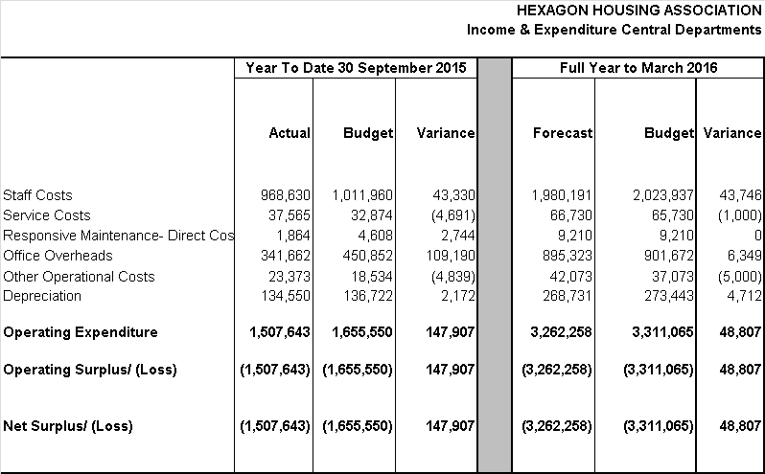

Staff costs are underspent by £43k, including £35k in Business Improvement where recruitment for one new post was delayed and another post is vacant.

Service cost is overspent by £5k. This is mainly in furniture expense due to the second instalment payment for office carpeting. The variance is expected to reduce as the budget is phased equally over 12 months.

Office overheads is underspent by £109k, areas of underspend include computer maintenance £25k, consultancy £16k, central & departmental training £20k and advertising £12k.

12 | 12 Balance Sheet  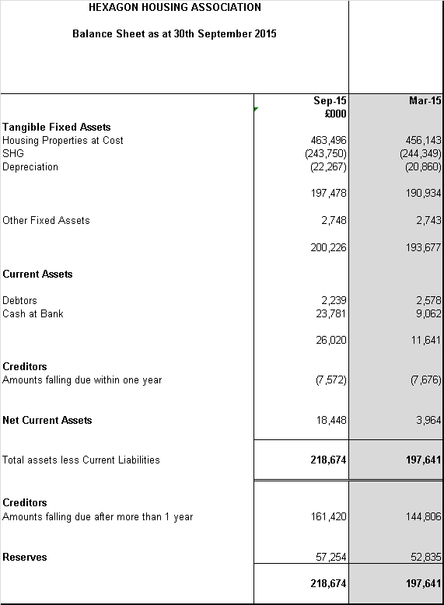  13 Sundry(non rent) Debtors  Debts of over 3 months stand at £161k (June quarter £221k). Two Co-ops that had debts of over three months in the June quarter have now paid. Southwark is the highest outstanding debt with £78k at the moment. Finance and Supported Housing managers are in contact with Southwark. Out of this amount £11k relates to Highshore Road void funding which they are disputing.  The main accounts outstanding are as follows,  14 Conclusion  Net surplus for the 6 months to September 2015 is £4,360k (budget £4,460k) £99k below budget.  The highest overspend against budget is in responsive repairs at £419k. Another area of overspend is cyclical maintenance at £134k above budget. However this due to timing and we are forecasting we will have an underspend of £106k by the end of the year.  There have been positive variances in areas such as staff costs, operational costs and office overheads. These variances are mostly due to the way budgets have been phased and will likely catch up with their spends during the course of the year except for staff cost where we are forecasting that we will have £203k underspend by the end of the year from unfilled posts and new bids not yet recruited. The current underspend in SIP revenue however is timing and we expect it to be overspent by £67k by the end of the year.  The forecast to the end of the year shows that we will have an overall operating surplus less than budget by £271k and net surplus being lower than budget by £339k mainly as result of responsive maintenance, rent and service charges income. However, there will be savings from staff costs (£203k) and cyclical maintenance (£108k).  Control of the responsive repairs budget will be key to bringing the full year result closer to budget. An action plan has been put in place by the Property Services Director, and shared with the Lead Board Member.
  Customer | Debt of over 3 months | Comment
   | £’000
  London Borough of Southwark | 78 | Amount owed relates mainly to void funding for different schemes. Ongoing dialogue with Hexagon staff regarding settling this amount.
  Tenant Recharges | 28 | Recharges to tenants
  Turning Point | 20 | This debt is gradually reducing. An agreement has been reached with Turning point to clear this debt. Having paid £3.7k towards this debt they are now paying a monthly instalment of £618.07 for the term of the lease.
  Three Cs | 9 | Co-op. Expected to be paid.
 | Semegne Alemayehu
Finance Manager

