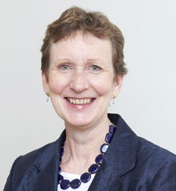
- Dr Fiona Underwood
- Partner
- 07788 643 092
- fiona.underwood@altairltd.co.uk
- Dr Fiona Underwood
- @AltairLtd
Dr Fiona Underwood

Expertise
Governance, strategy development, mergers and acquisitions, regulatory issues, investigation work, project management, mentoring senior executives and Board members.

About
Fiona has worked in a wide array of sectors and brings a wealth of experience into her role as an adviser to boards and executive teams. She specialises in governance and strategy, and possesses wider expertise in project management, process reviews, organisational development, coaching and mentoring.
Fiona has managed businesses and has gained further experience of the private sector through work on mergers and acquisitions, and leading large-scale transformation programmes.

Altair Assignments
Recent projects that Fiona has been involved in include:
- Governance advice and support
- Governance reviews for numerous RPs
- Leading strategy sessions for boards and executive teams
- Assisting in the development of an organisation’s risk appetite
- Leading boards through scenario-planning exercises
- Lead adviser roles in numerous mergers
- Special manager assignments in Scotland
- Coaching and mentoring for Chairs, Non-Executive Directors and Executive Directors
- Investigations resulting from whistleblowing and regulatory action

Background
Tribal Consulting – Managing Director of Housing, Regeneration and Local Government; Director of Strategy and Housing Practice
KPMG – Senior Business Advisor
CBI – Head of Competitiveness and Business Performance, Head of Manufacturing Industries and Technology
BAE Systems – Various roles
Independent consultancy work

Publications
Author of the Cosmopolitan “Lessons Learned” report

