Hexagon Housing Association

Board

27th September 2016

Lead Board Member – Martin Large

Report by the Finance and IT Director

Agenda Item X

Progress to date on the Value for Money Strategy and the Value for Money Self - Assessment

1.0 Summary

Hexagon is making progress on many of the value for money targets set by the Board, although there are some areas where no progress has been made.
The attached Value for Money Self – Assessment sets out, in a way that is transparent and accessible to stakeholders, how Hexagon is achieving VFM in delivering our purpose and objectives.
_____________________________________________________________

- Recommendation
The Board is asked to:
- Note the progress against the current Value for Money Strategy
- Approve the 2016 Value for Money Self Assessment

3.0 Background

  - The Board agreed a three-year Value for Money Strategy in May 2014 which included both interim and final targets across 45 cost and quality indicators. This report set out the progress made to date.

  - At the recent Board awayday, the Board appraised its performance on driving the organisation’s VFM performance and made suggestions for improvement. These will be considered as part of the next VFM strategy. In the meantime, a Red-Orange-Green colour coding has been used in this report to show progress against each of the 45 indicators.

  - The HCA’s regulatory standard on value for money sets out specific expectations of registered providers. It also requires the Board to publish a robust self assessment of how the Association is achieving value for money in delivering its purpose and objectives. A copy of the Value for Money Self Assessment is attached at Appendix 2. This will be published on Hexagon’s website within a day of approval by the Board. A summary has already been included in the financial statements.

  - The section of Hexagon’s website that addresses VFM in more resident- friendly terms will also be updated.

- Progress against the 14/17 VFM Strategy

4.1 Progress against the 45 targets in the 14/17 VFM Strategy agreed in May 14 is set out in Appendix 1 (which also forms App C of the VFM Self Assessment). There has been some progress - of the 45 targets, 18 have been met. 22 have not been met, but there has been some improvement on 7 of these. Of the remainder, 3 are not relevant for 15/16 and we have not been able to collect data on 2. By way of comparison, 19 of the targets had been met when we reported this time last year.

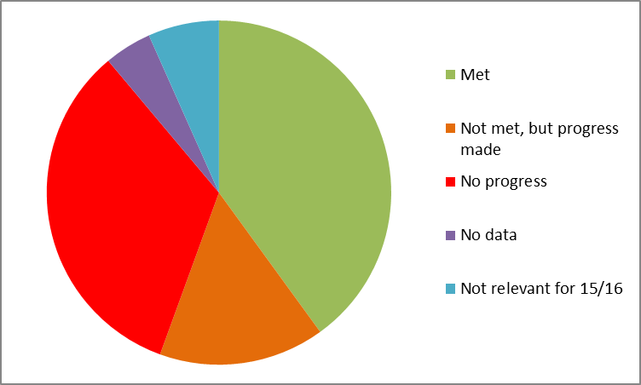

4.2 7 out of the 15 targets where Hexagon has not made progress are those that involve resident satisfaction, mainly around repairs. Officers believe that these disappointing results are likely to be a hangover from the deterioration in the repairs service under RR Richardson. KPIs indicate that the responsive repairs service continues to improve, so it is hoped that satisfaction levels will follow.

4.3 Other targets where we have not been able to improve are set out below, along with the current actions intended rectify this.

Target | Action to improve
Development programme build cost - we had to revise the target upwards after it was set, but even this proved impossible to meet in the current market conditions. This was discussed with the Board several times during the year | No further actions proposed, as there have also been increases in rental and market values, so the programme is still within the subsidy set by the Board. All contract costs are supported by a VFM statement from the employers agent.
Major repairs cost per property to be better than the top quartile for London | There is a continuous programme of tendering to ensure that costs are competitive. The most expensive voids are assessed for disposal.
% repairs completed at first visit to be at least 94% | Responsive repairs contracts for 16/7 onwards include penalties for contractors if targets are missed
Responsive repairs cost per property to be less than £445 in 14/15 | New contracts are in place, with a full IT interface to maintain controls over variations and invoice approval. Responsive Repairs Manager approvals all orders over £500
Void rent loss to be less than 0.75% | The target was met in 14/15 but not in 15/16. We should be able to meet the target for 16/17 as we are now assessing fewer homes for disposal.
Cost per void repair (those under £2000) to be less than £1497 | The target was met in 14/15 but not in 15/16. Costs are monitored and discussed with the voids surveyor at meetings with her line manager.
Void turnaround in supported housing where not funded by the commissioning authority to be less than 34 days. | The team are looking at ways of preventing unsuitable referrals.
Cost per property of providing estate services to be no more than 70% of top quartile in London | Cleaning and grounds maintenance contracts have been tendered, producing an anticipated reduction in costs. However, we do need to also minimise the loss on service charges as well.

4.4 Appendix E of the VFM Self Assessment lists the actions to be taken in 16/17 as part of the VFM strategy.

4.5 A 3-year new VFM strategy will be developed by the end of March 2017. Officers will work with the Lead Board Member to make sure that the strategy is clear on strategic direction as well as having the measurable operational targets that provide the golden thread into departmental and individual officer objectives.

5.0 How the VFM self assessment meets the HCA requirements

The HCA VFM standard sets a specific expectation that the assessment shall:

- Enable stakeholders to understand the return on assets measured against the organisation’s objectives
- Set out the absolute and comparative costs of delivering specific services
- Evidence the value for money gains that have been and will be made and how these have and will be realised over time

The self assessment uses these headings to make it easy for the HCA to check for compliance.

6.0 How the Board gains assurance on VFM

The required outcomes of the HCA VFM standard are set out in Appendix 3, together with how the Board gains assurance that Hexagon meets the standard.

