Hexagon Housing Association

2016/7 Value for Money Self – Assessment

1. **Introduction**

Why Value for Money is important

For Hexagon, Value for Money (VFM) is about being effective in how we plan, manage and operate our business, it is important because

* Residents pay their rent and service charges in the expectation that we will make the best use of them to fulfil Hexagon’s objectives;
* Our main source of income (social housing rents) is constrained by a long term formula that links it to inflation +1%. Further constraints have been introduced by the Government, which means that most of our rents will reduce by 1% a year for four years from July 2016. We have to ensure that other costs rise by no more than rental income over the long term to secure Hexagon’s long term future; and
* Our regulators place great emphasis on VFM

How the Board monitors VFM

Our Board obtains assurance on VFM through a range of means including:

* Setting targets for a set of 9 important indicators, as part of the 3-year corporate plan
* Approving an annual VFM strategy to improve performance across six VFM themes
* Reviewing delivery of the VFM Strategy once a year
* Approving the annual Self-Assessment
* A range of quarterly performance data which covers quality issues.

The Board has recently set up a Performance Sub-Committee to focus on improving both performance and VFM. This Sub-Committee will be meeting quarterly from October 2017.

1. **Overall assessment**

2.1 Value for money is about outputs, outcomes and resident satisfaction as well as costs. Hexagon performs well in overall value for money, with particular strengths being as follows:

* Our key services are provided at lower cost than average for London housing associations (see section 6)
* Our interest costs are lower than the median for English housing associations (paragraph 4.1)
* All of our directly managed general needs homes produce a positive financial return, as measured by net present value (section 8)
* We have an approach to VFM Strategy that contains challenging and measurable targets

2.2 However, there are some specific areas where we want to do better, as follows:

* Although resident satisfaction with our responsive repairs service (as measured by satisfaction with the last repair) is gradually improving, this is still significantly below the median for the sector (see paragraph 4.1)
* Our rent collection rate is below the median for the sector (see section 7)
* Despite the difficulties of making our Victorian and Edwardian street properties energy-efficient, we are investing significant amounts of money to improve the average SAP rating of our homes.

All of these areas feature in our VFM strategy for 17/18.

1. **How we define and measure value for money at Hexagon**

3.1 Hexagon’s VFM approach has 6 strategic Value for Money themes:

* Restricting operating costs (including major repairs and void losses) per social housing unit
* Restricting the growth of interest costs per social housing unit
* Effective asset management
* Maximising development (within our capacity)
* Improving resident satisfaction
* Delivering social value

|  |
| --- |
| * 1. The Board has agreed a suite of high level measures which allow progress to tracked on each of the themes and cover all of the Association’s activities: |

|  |  |
| --- | --- |
| Theme | Measure |
| Restricting operating costs (including major repairs and void losses) per social housing unit | Operating cost per social housing unit |
| Restricting growth of interest costs per social housing unit | Interest paid as a percentage of average borrowings |
| Effective asset management | Return on capital employed |
| Maximising development (within our capacity) | Units developed as a percentage of units owned |
| Maximising development (within our capacity) | £m distance from an interest cover breach |
| Maximising development (within our capacity) | Cumulative surplus on outright sales |
| Improving resident satisfaction | % satisfied with last repair |
| Delivering social value | Average SAP rating of properties |
| Delivering social value | Annual social value delivered per £ spent on employment initiatives |
| These measures have been chosen because they encompass everything that the Association spends, but also include the most readily available measures of outcome (new homes, resident satisfaction and social value). Definitions of each measure are included in the Association’s Value for Money Strategy | |

Three-year targets for each of the measures have been set for the period from April 2017 to March 2020, so that the Board can monitor progress in delivering VFM over the course of the three-year corporate planning period. Hexagon has also signed up to a sector-wide initiative to compare 21 VFM indicators, known as the “Sector Scorecard”. Initial results from the sector scorecard are set out in section 7 below.

1. Outcomes against the high level VFM measures

4.1 Although the high level measures were only agreed in March 2017, they are set out here to provide a baseline for reporting progress in future years, and to show how other English housing associations compare, where this is available.

|  |  |  |  |
| --- | --- | --- | --- |
| Year to | 2017 | Other landlords (median) | Source of comparative |
| Operating costs per directly managed social housing unit (£/ unit) | £4221 | £3055 | Global accounts 15/16 |
| Weighted interest rate | 2.97% | 4.94% | Global accounts 15/16 |
| Return on capital employed | 2.34% | 4.11% | Sector scorecard 16/17 |
| Units developed as a % of units owned | 1.2% | 1.13% | Sector scorecard 16/17 |
| £m distance from an interest cover breach (cannot be less than £5.1m) | £12.7m | Not available | - |
| Cumulative return on outright sale schemes (£'000) | 0 | Not available | - |
| % satisfied with last repair | 80.9% | 88.4% | HouseMark 2014/15 (little comparable data 2015/16) |
| Average SAP rating of properties | 71.84 | 71.6 | HouseMark 2015/16 |
| Annual social value delivered per £ spent on employment initiatives | 6.13 | N/A | Nearest comparative is £s generated for every £ invested in communities, but there is insufficient data on this Sector Scorecard measure this year. |

|  |  |
| --- | --- |
|  | As can be seen in the table above, Hexagon’s costs per unit are much higher than the average for English housing associations; however, much of this relates to London factors – such as higher staffing, repairs and building costs.  The chart to the left looks at just London associations using a HouseMark tool for the 15/16 data from the HCA – this shows that Hexagon (the orange star on the chart) comfortably inside the cheapest quarter. This relative position remains when excluding associations who are recent stock transfers, or have larger amounts of supported housing than Hexagon – two of the other main factors other than location that the HCA found to explain differences between Associations.  There is more on the HouseMark Analysis at  <https://www.housemark.co.uk/subscriber-tools/data-and-analysis/global-accounts-storyboard> |

1. Trends on operating costs per unit
   1. The graph below shows Hexagon’s costs per unit in management, in the way that the HCA calculates this. 1 Most (79%) of the costs describes as “other” for homes managed by co-ops and supported housing agencies or for support services which are funded by local authorities.
   2. This graph shows how rising amounts spent on major repairs are driving the increase in cost per unit, but in 16/17 much of this was because of repairs to a new scheme (Brickfield Cottages) affected by a ground collapse. The last column in the graph shows the cost per unit for 16/17 excluding the amount spent on Brickfield Cottages. Even with this adjustment, the costs per unit are rising slightly faster than rent inflation (which was negative in 16/17 as rents are now being reduced by 1% a year).

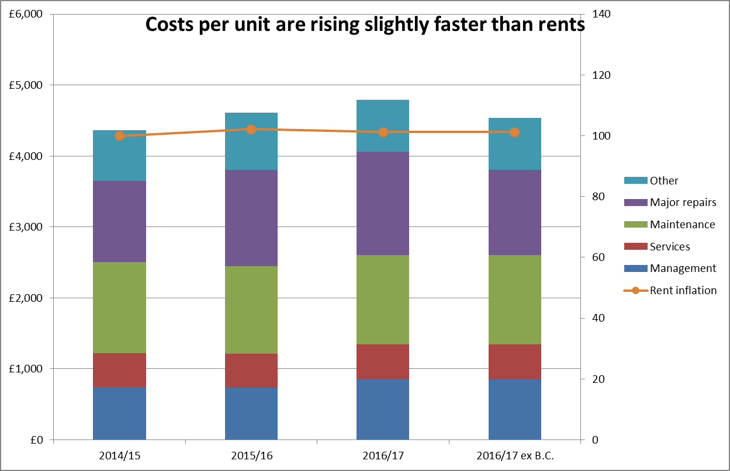

1 The HCA calculation includes our costs for 471 units managed by co-ops and supported housing agencies, but excludes these from the unit count. The opposite is true for our 12 units in a nursing home. This reduces its usefulness, but the trend will be roughly right.

1. How our services compared on cost and quality with other London housing associations

6.1 Value for money is about outputs and outcomes as well as costs. We use HouseMark to help us measure this – the most recent summary data from HouseMark for 2015/16 (see chart below) shows that for all the indicators Hexagon’s costs were low cost, although Rent Arrears and Tenancy Management are the only areas in the green ‘good performance, low cost quadrant’; the remaining five areas are in the ‘poor performance, low cost’ quadrant, although Estate Services, Major Works and Lettings are all on the cusp on ‘good performance’.

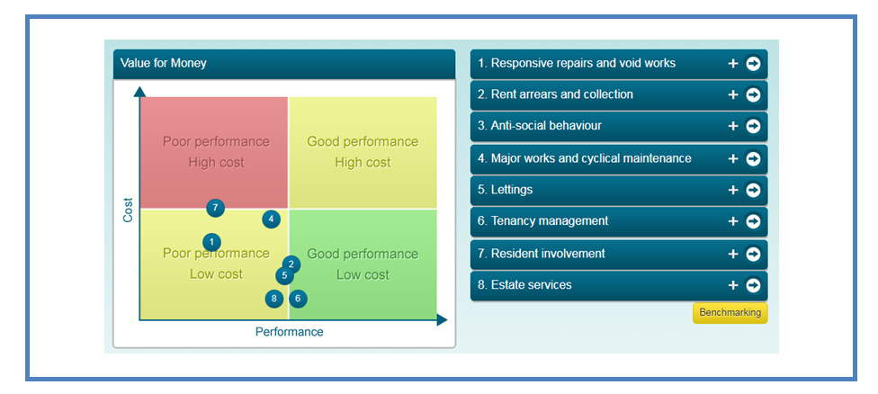

We use the HouseMark data each year to help identify areas where we need to improve on performance or costs as part of the process of developing both departmental workplans and in the new annual VFM strategy.

6.2 The 2015/16 data is not that dissimilar to the previous two years as the two graphs below show, although those in ‘poor performance, low cost’ tend to be closer to ‘good performance’ than was the case in previous years.

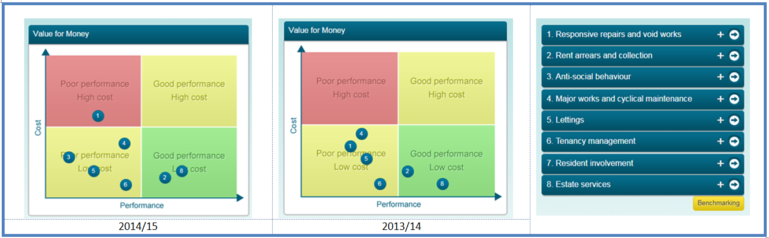

6.3 A few notes are worth making, with each of the broad areas a basket of cost and performance measure is used to which HouseMark applies weightings. Generally, Hexagon uses a benchmark of all London housing associations for HouseMark, however, this graphical dashboard has slightly more limited options and the nearest to our benchmark is London associations with less than 7500 homes. As the size of the benchmark is relatively small and not necessarily the same organisations submit data every year, there can be fluctuations. Resident involvement only appeared in the 2015/16 data as in previous years it required the collection of profile information in regards to religion and sexual orientation, something which we have not collected. ASB only appeared in 2014/15 because of a lack of data on service satisfaction in other years.

1. How our costs and outcomes compared with other housing associations across England

7.1 The Sector Scorecard is set of 15 indicators that are being piloted to benchmark efficiency across the sector in 2016/17 with a full launch planned for 2018. The indicators are split across five categories of business health, development (capacity and supply), outcomes delivered, effective asset management and operating efficiencies, some of the indicators have sub divisions so there are 20 indicators in total. Data was supplied by just over 240 housing associations, local authorities and ALMOs. Unlike the HouseMark data used there is a single national dataset with no ability at present to benchmark by region, for example.

7.2 The results for Hexagon are shown below graphically quite mixed – 8 (in green) are above the median, 9 (in red) are worse than the median and with three (in blue) data is missing. The areas where we are worse are generally either:

* Those that we either know about and are trying to resolve and have actions as part of the new Corporate Plan
  + Rent collection; and
  + Overall satisfaction with the landlord;
* Do not exclude the unusual costs of Brickfields Cottages
  + Operating margin ; and
  + Major repairs costs per unit;
* Do not reflect accurately the units that Hexagon is responsible for – the denominator is the number of units managed, this does not take into account the number of homes managed by Co-ops and other agencies on our behalf which are atypical for our size
  + Major repairs; and
  + Other social housing costs per unit;
* Some relate to being a London landlord with a large percentage of Victorian and Edwardian homes
  + Major repairs costs per unit; and
  + Maintenance costs per unit.

There is one major exception to this – return on capital employed. Hexagon’s relative position in the bottom quartile was not expected and requires some extra work to understand the reasons for this.



1. Our return on assets

8.1 During the year we have been working to implement a software tool to look at the financial return on each of Hexagon’s properties. The initial results are encouraging for our Directly Managed General Needs homes, where there are no homes with negative Net Present Values, as the graph below shows. We intend to extend the analysis to Co-op Managed, Supported Housing and Shared Ownership homes by the end of the current financial year.

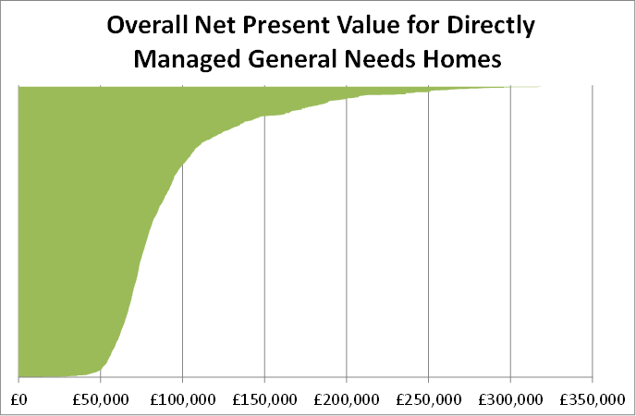

8.2 At least part of the reason for the lack of units with negative Net Present Values is that in recent years we have actively reviewed homes that have become void and using a slightly less sophisticated analysis have disposed of the uneconomic to repair units. In the five and a half years to March 2017, 80 homes have been reviewed as part of this process – with 36 homes which were not cost effective to bring up to current standards being sold.

1. **Value for money gains that have been made as a result of the 2014/17 VFM Strategy**

9.1 This report also reports on the final year of the 2014/17 VFM Strategy which the Board approved in May 2014, it focussed on six main areas

• Responsive repairs and voids

• New homes

• Asset Management

• Estate Services

• Supported Housing Voids

• Treasury Management

9.2 45 measurable targets covering both quality (21) and costs/efficiency (24) were included in the strategy, which also includes actions to achieve the targets and to embed value for money throughout the organisation. 41 of these related to 2016/17 as not every target related to each year – for example, several were linked to Development Programmes that only applied for part of the 3 year strategy.

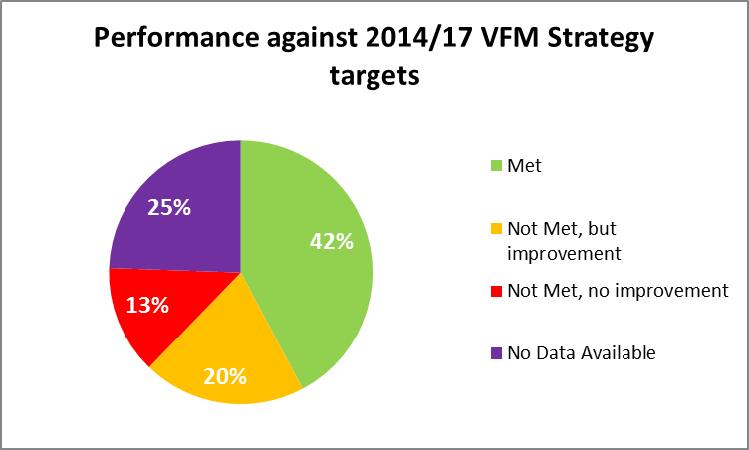

9.3 42% (19) were achieved in either 2017 or the final year to which they related. 20% (9) were not met but saw some improvement during the strategy, this included targets which with hindsight were over-ambitious – the target for no homes to have a SAP rating of less than 65 (excluding residents who refuse work) falls into this category. A more realistic, longer-term target has been which we are on course to meet. These issues were reflected on in our changes to the approach to VFM from 2017. A further 13% (6) of targets were not met – some of this group were overtaken by events – such as those relating to cost per square metre for new homes where the market changed over the three years and what seemed a realistic target at the start of the strategy was no longer the case three years later.

9.4 Of the eleven sets of missing data (25% of the chart), most of these relate to the time-lag in availability of 2016/17 HouseMark data, although there have been a small number where there was insufficient data to produce meaningful results – an example of this was satisfaction levels with New Homes.

|  |
| --- |
| Love London Working – A Case Study  Hexagon is working with 16 other housing associations on a three year pan-London European Social Fund (ESF) funded project which is enhancing our business start-up and employment support work. It is helping Hexagon residents and others in the communities that we work with into employment through a variety of methods – including help to write CVs, interview practice, help with looking for work, placements within the Association and help with business start-ups. The financial input from Hexagon is not significantly more than we would have committed to this sort of work anyway but we have been able to considerably expand the level of our operation.  In numbers during 2016/17:   * Hexagon had a budget of £89,180 for Love London Working; * We secured £44,590 grant income which made up 50% of the budget; * We generated £546,308 in social value; and * That means for every £1 we spent, we generated £6.13 of social value.   **Eric’s Story**  Numbers don’t give the full picture though; Eric’s story shows how much difference our input can make. We ‘met’ Eric at a local Food Bank. He was recovering from alcohol abuse and a recent stint of homelessness but was still ‘sofa surfing.’ He lacked the confidence and skills to make successful job applications for customer service roles within supermarkets which he was looking for. Eric also lacked basic IT skills and suitable clothes for interviews. Directly or through referrals to partner agencies we helped Eric:   * Compile a tailored CV and cover letter; * Gain basic IT skills so that he could send e mails and attach his CV & search on-line for jobs; * With mock-interviews; and * Getting suitable interview attire.   Within a few weeks Eric got two part-time jobs with supermarkets totalling 40 hours work a week. We continued to support him through the transitional period between benefits and his first wage packet. He was offered a local authority flat, but was worried that he would need to take on another job to furnish it – so we helped Eric apply to a charity so that he could buy furniture.  A year on from the first meeting with Eric, he is still working for Iceland and Sainsbury’s and is very happy living in his fully furnished flat. He is very excited and proud that he has booked and paid for his first holiday in 20 years. Eric will be visiting old friends and family members in Jamaica in January 2018! |

9.5 While our Strategy underpins our approach to Value for Money, everyone in Hexagon is encouraged to consider VFM in their day to day work. Examples VFM successes during 16/17 which were not part of the 14/17 VFM Strategy include:

* Bringing in extra resources for Employment and Skills through Love London Working (see case study above);
* Stopping sending out physical rent statements with Home News magazine – saving around £7,000 a year;
* Saving around £1600 by renegotiating the IT support package on Sun Accounts; and
* Completing the procurement of a new Housing Management and maintenance IT system, Civica’s Cx, during the year (see case study below).

|  |
| --- |
| **Civica’s Cx – A Value for Money Case Study**  Sometimes some up-front investment is needed to achieve value for money in the longer term. This is certainly true with IT – our ageing main housing management and maintenance IT systems were holding us back, preventing us working smarter and interacting with residents in ways that they expect from service providers in 2017.  After an exhaustive and competitive process we selected Civica’s Cx product (screenshot above). Cx is a very modern system using Microsoft .net technologies which has a fresh look and feel. As it goes live Hexagon will be able to   * Improve our communications with residents – particularly through text and e mail; * Allow residents to use channels other than telephone to access services; * Allow us to gain a better understanding of our customers’ needs and requirements to enable us to tailor our service offer more effectively; * Allow staff to work as effectively as we would like away from their desks; and * Allow us to digitise our filing and documents.     In the longer term these changes will allow us to work much more effectively, provide a better service to our residents and need much less office space for filing. |

**10.0 Value for money gains to be made in 17/18**

10.1 Based on the evidence from benchmarking data, we intend to focus on controlling responsive repair costs and on improving resident satisfaction. Past experience has shown that if residents are happy with responsive repairs and (to a lesser extent) with estate services such as cleaning and gardening, then other satisfaction measures also rise. Also, although our current performance on rent collection and arrears is good, this is beginning to deteriorate and we need to reverse the trend.

10.2 The 17/18 VFM Strategy includes a set of 20 actions to improve VFM. A full list of the actions is shown in section 5 of the strategy, but the most important ones are set out below.

|  |  |  |
| --- | --- | --- |
|  | | |
| **Theme** | **Initiative** | | **Team responsible or leading** |
| Restricting operating costs | Implementation of Cx computer system to replace existing housing management and maintenance system | | Business Improvement |
| Restricting operating costs | Achieve some challenging targets on arrears & rent collection in relation to all the business streams - including rent collection rates of 99.5% & General Needs arrears target of 5.6% | | Housing Services |
| Restricting operating costs | More frequent monitoring of high value orders to ensure than costs are contained. | | Responsive Repairs |
| Effective asset management | Continue review of Hexagon’s estates to identify land for further development. | | Development & Regeneration Director |
| Effective asset management | Dispose of properties where detailed assessment suggests that they are uneconomic to repair, maintain or let in the longer term. | | Stock Improvement |
| Maximising development | Secure grant funding to develop homes under the 2016-2021 GLA funded development programme, generating cross subsidy of £3.7m through outright sales. | | New Business |
| Improving resident satisfaction | Introduce PDA based surveys for repairs work to give more immediate feedback and allow us to deal with problems earlier; and set more challenging targets for satisfaction - such as 90% for the gas contractor. | | Responsive Repairs |
| Delivering social value | Ensure effective delivery of Love London Working Project, including - enrolling 200 participants (at least 100 of which are residents) - getting at least 104 into employment (including 52 residents) | | Community Investment |